West Morris Central Football
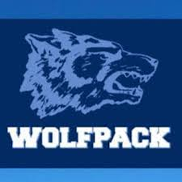
Dine Out Fundraiser
at
OMG Burger & Brew
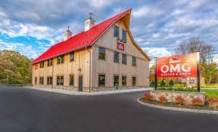

Present this flyer to OMG Burger & Brew from September 5th- September 19th as Wolfpack Football will receive 15% of total sales.

Thank you for support to the Wolfpack Football Parents Club and the players.

GO PACK!

